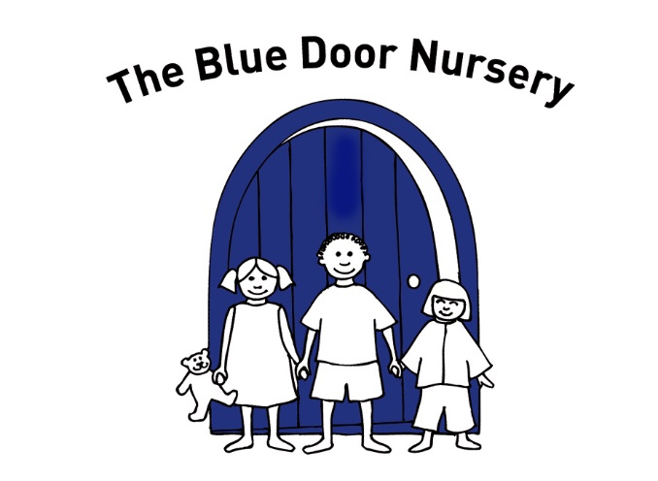
Autumn Newsletter 2022
- All about staff
- Nursery updates
- Session bookings
- Reminders
- Dates for your diary
- Information about increase cost of meals at nursery

Nursery updates
We’ve been delighted to welcome our families back through the front door at drop off and pick up times and would like to thank everyone for their patience while we’ve been getting to know who’s who again! Drop offs and pick ups now happen at all session times from the front door, parents and carers should come into the nursery with their children. When leaving, please do not open the front door yourselves – you must be seen out of the nursery by a member of staff.
We have been continuing to learn more about sustainability as a staff team and working with children and families to try and be as ‘eco-friendly’ as we can be. We have already purchased a water butt which the children enjoy collecting water from to water plants and make paints with and paper recycling bins for our rooms. We have also encouraged parents to provide cloth bags for changes of clothes to reduce use of plastic bags.
Our Blue Door stay and play sessions in nursery have proved popular – parents have been bringing siblings, yet to start at nursery, to get a ‘feel’ for what we get up to. The dates for the next few sessions are at the end of the newsletter- get them in your diary!
We have no plans to increase the ratios at Blue Door, whatever the Government says…

Blue Door staff
Lauren (Cubs) finished her dissertation for her Early Years degree in the Summer and was awarded a distinction and a First Class honours overall.
Claire (Lions) is continuing to add to her skills, knowledge and qualifications and is just finishing her SEND qualification which will allow her to support Ruth, our SENDCo.
Isobel (Kittens) is in the last stages of her management qualification and is growing in confidence as she deals with the day to day issues of running a busy nursery!
Chloe, Lauren H, Louise and Tonisha have been working hard and are nearing the completion of their Level 3 qualifications.
All staff have been busy updating specific areas of training to extend and develop their professional experience.
Kerry (Cubs) and Rosie have both settled really well into the team and are bringing a wealth of knowledge and experience to the groups.
Sadly, we will be saying goodbye to Kerry in the Kittens’ team at the end of November. Kerry has decided to go travelling with her partner – we wish her well in her new venture!

Diary dates
8th December Zebedees’ Christmas dinner at nursery
16th December End of term for term time only children
23rd December Nursery closes for Christmas
3rd January Nursery reopens for all except term-time only funded children
9th January Spring term funding begins
Spring half term 13th February to 17th February
Stay and play sessions Tuesday 10th Jan,24th Jan, 7th Feb, 28th Feb, 14th March
(1.45-2.30pm) Thursday 8th Jan, 19th Jan, 2nd Feb, 23rd Feb, 9th March
Increase to meal costs from January 2023
As you know, for the last few years we have been subsiding the cost of meals for children who attend nursery all day, but unfortunately, in light of rising costs, from January we will not be able to continue this . We need to increase the price of some sessions to reflect the increased costs of providing meals at nursery. We have managed to absorb the increased charges from Zebedees over the last year or so but this is not sustainable in the longer term.
If your child only attends fully paid for (i.e. not government funded) sessions in the morning or afternoon there will be no increase in January unless your child has a special dietary requirement. The whole day session will increase in price.
We understand that in this challenging economic climate any increase in costs can be difficult and so if your child attends all day and you do not wish to continue with the Zebedees meals, you may provide your child with a cold packed lunch with no increase in fees at the current time. Packed lunches must be in a single, named lunch box and must have an ice block included (we have no cold storage facilities). We will not be able to heat packed lunches.
Broadly speaking, the increases are as follows:
Morning sessions
For non- funded children on morning sessions there is no increase if your child has a standard lunch and a 27p increase if your child has a special dietary requirement.
Afternoon sessions
No increase
Whole day sessions
For non- funded children on whole day sessions there is an increase of between 27p and £1.99, depending on the session length / type.
Government funded sessions
All funded sessions that include lunch will increase by £1.50, with the option of keeping the price the same but providing a packed lunch.
Full cost details for your child’s age group have been attached to Tapestry so that you can see what your new cost will be. As always, if you wish to change sessions to reduce costs please let us know via email bluedoornursery@gmail.com
We will assume that your child will continue with hot lunches from Zebedees unless you advise otherwise. You can mix packed lunches and hot lunches during the week – but once you have told us the pattern it needs to remain unchanged.
All fees will be reviewed next year (for April) to take account of increased costs, raises to minimum wage etc. You will be advised of these in March.

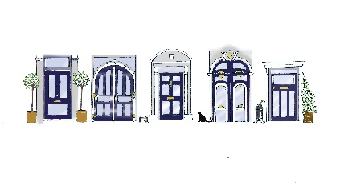
Reminders
Late pick-ups: Please remember that drop offs and collections should be in line with your booked sessions, we have some creeping earlier and later! If you need extra time please let us know so that we can charge accordingly. If you are early pleased be prepared to wait with your child until your scheduled start time.
Please make sure that your child has clothing appropriate for the cold weather coat, hat and wellies – which has their name on!
Our floor gets a little cold this time of year, please provide a change of foot wear if your child wears wellies to nursery – shoes, slippers or plimsols.
Please remove any medicines/creams from your child’s nursery bag before hanging it on your child’s peg – if your child needs them, please talk to your child’s team so that they can be signed in stored safely
Can we please remind everyone to refrain from using mobile phones once inside the nursery – this is to safeguard children, staff and other parents.
If you need extra sessions for your child or need to make changes to sessions please email them into the office as staff are very busy with the children.

It is end of term for term time only children on 16th December. Funded children return on 9th January, everyone else is back on 3rd January. Lisa has emailed regarding all funded children affected regarding sessions w/b 3rd, but not all parents have replied. All other children return after Christmas on Tuesday 3rd January. We close, normal time, on Friday 23rd December.
Christmas starts in earnest next week, w/b 5th December and all children will be learning Christmas songs, making Christmas cards and creating decorations to beautify your home.
The Lions will be singing Christmas carols at various times throughout the week beginning Monday 19th December – more details will follow on Tapestry
The Kittens and Cubs will be having a Christmas themed ‘Stay and Play’ afternoon session on Tuesday 20th December – more details will follow on Tapestry

Session bookings for next year
If you are looking to add to your existing sessions can you tell us now as we are getting a lot of enquiries!
Government funding 15/30 hours
- When your child is 3 they are entitled to 15 hours funding. The date of your child’s birthday is significant:
3 between 1st April and 31st August – eligible from September
3 between 1st September and 31st December – eligible from January
3 between 1st January and 31st March – eligible from April
Lisa will give you a form to sign for the 15 hours funding – every 3 year old child is eligible for this
- If you are eligible for the 30 hours (parents working more than 16 hours, earning less than 100k each)
You have to apply for the funding yourself – email Lisa and she will send you details
- The funding is only paid for 38 weeks of the year. So you can come 38 weeks and use 15 or 30 hours a week. Or, you can ‘stretch’ your hours and come all year round using 11 hours or 24 hours a week. Again, email Lisa for details.
- The funding does not cover the full cost of the session so you will be asked to pay a small contribution or provide nappies, wipes, snacks etc for your child. The funding we receive is £1.60 below the cost of providing the session.
- If your child is 3 before 31st March 2023 you will need to book whatever extra sessions you think you might need now – so that you get what you want. If you send Lisa an idea of what you ‘might’ need we can work out how much it will cost you, how much funding you are using and make sure that you are getting the best value for money out of the funding.

